Plotting Points Part 1:
From Graph to Coordinates

Learning Objective: Given points in the Cartesian plane, express them as an ordered pair.

Activity:
- Divide your group into 2 teams. Team Tarp grabs the bean bag markers and walks to the tarp. Team Map keeps this activity sheet.
- Team Map instructs Team Tarp to place bean bag markers at points A, B, and C from Set 1 below. How will you communicate where each point is located? What information will help Team Tarp place the markers?
- Once you have placed your markers, record their location in the table for Set 1 below.
- Repeat steps 2 and 3 for Sets 2 and 3.

Set 1
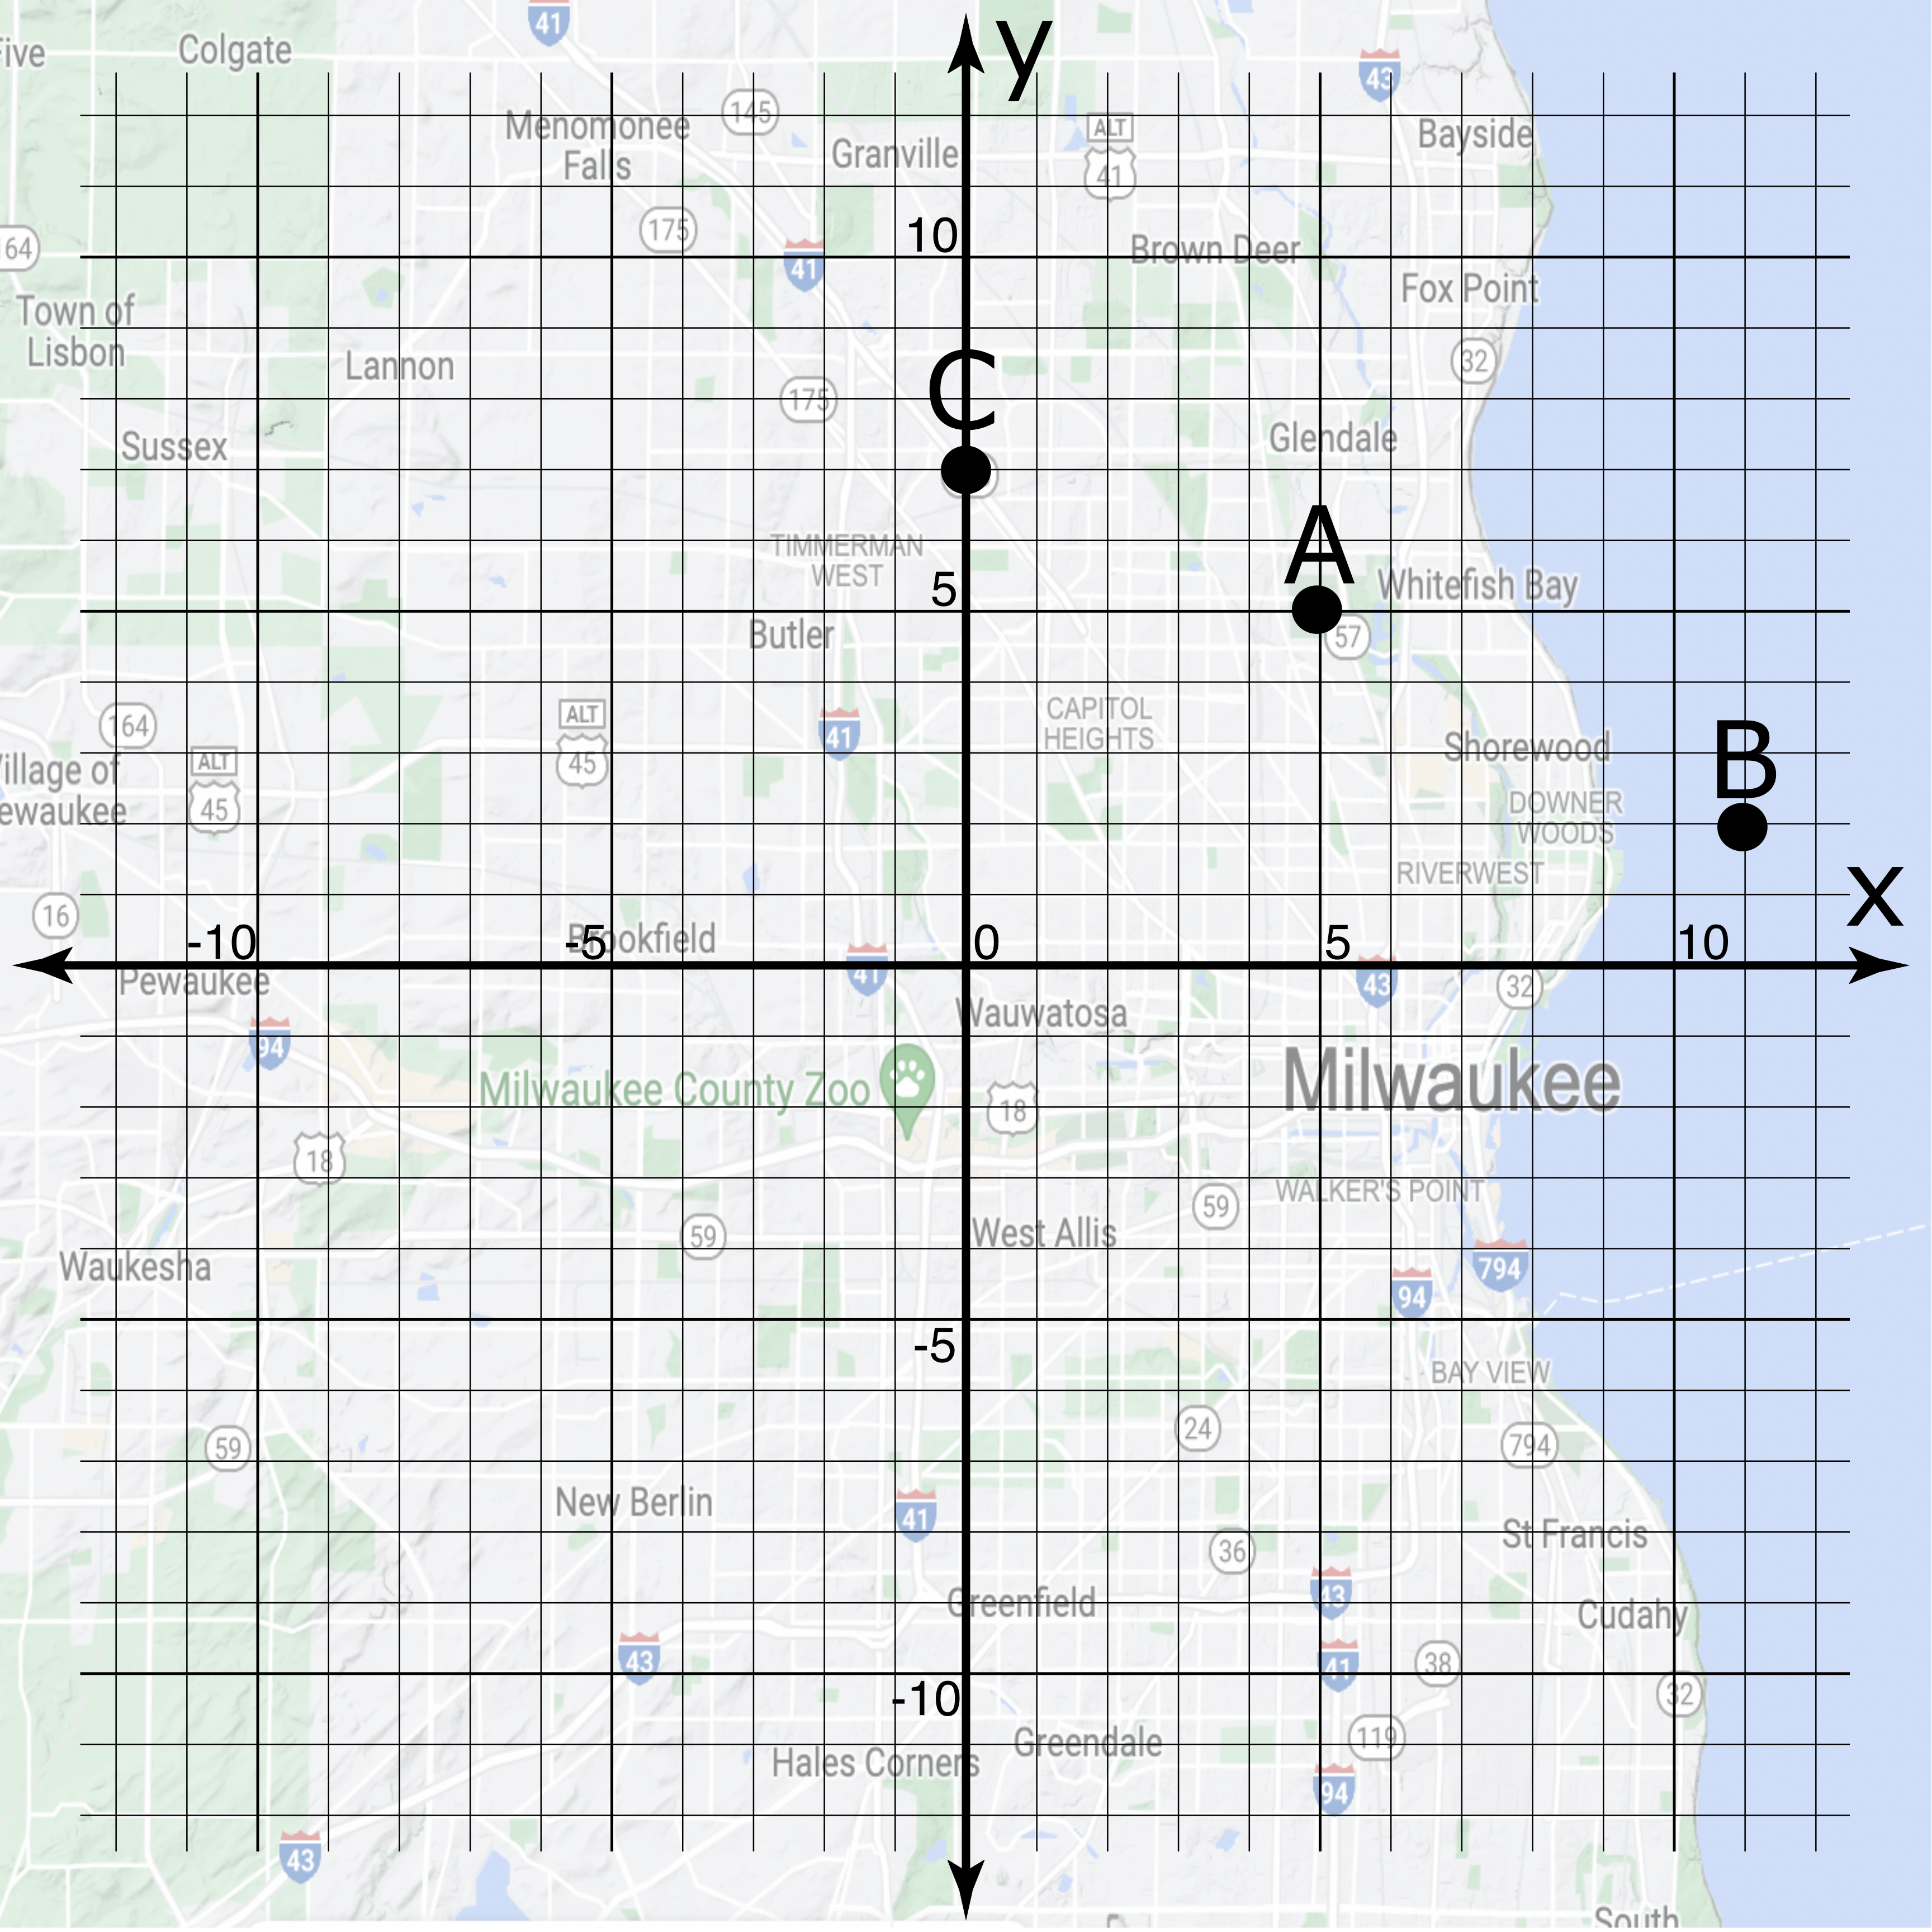
Graph of Set 1:
Set 1 locations:

Point | Location
1A | _________
1B | _________
1C | _________

Set 2
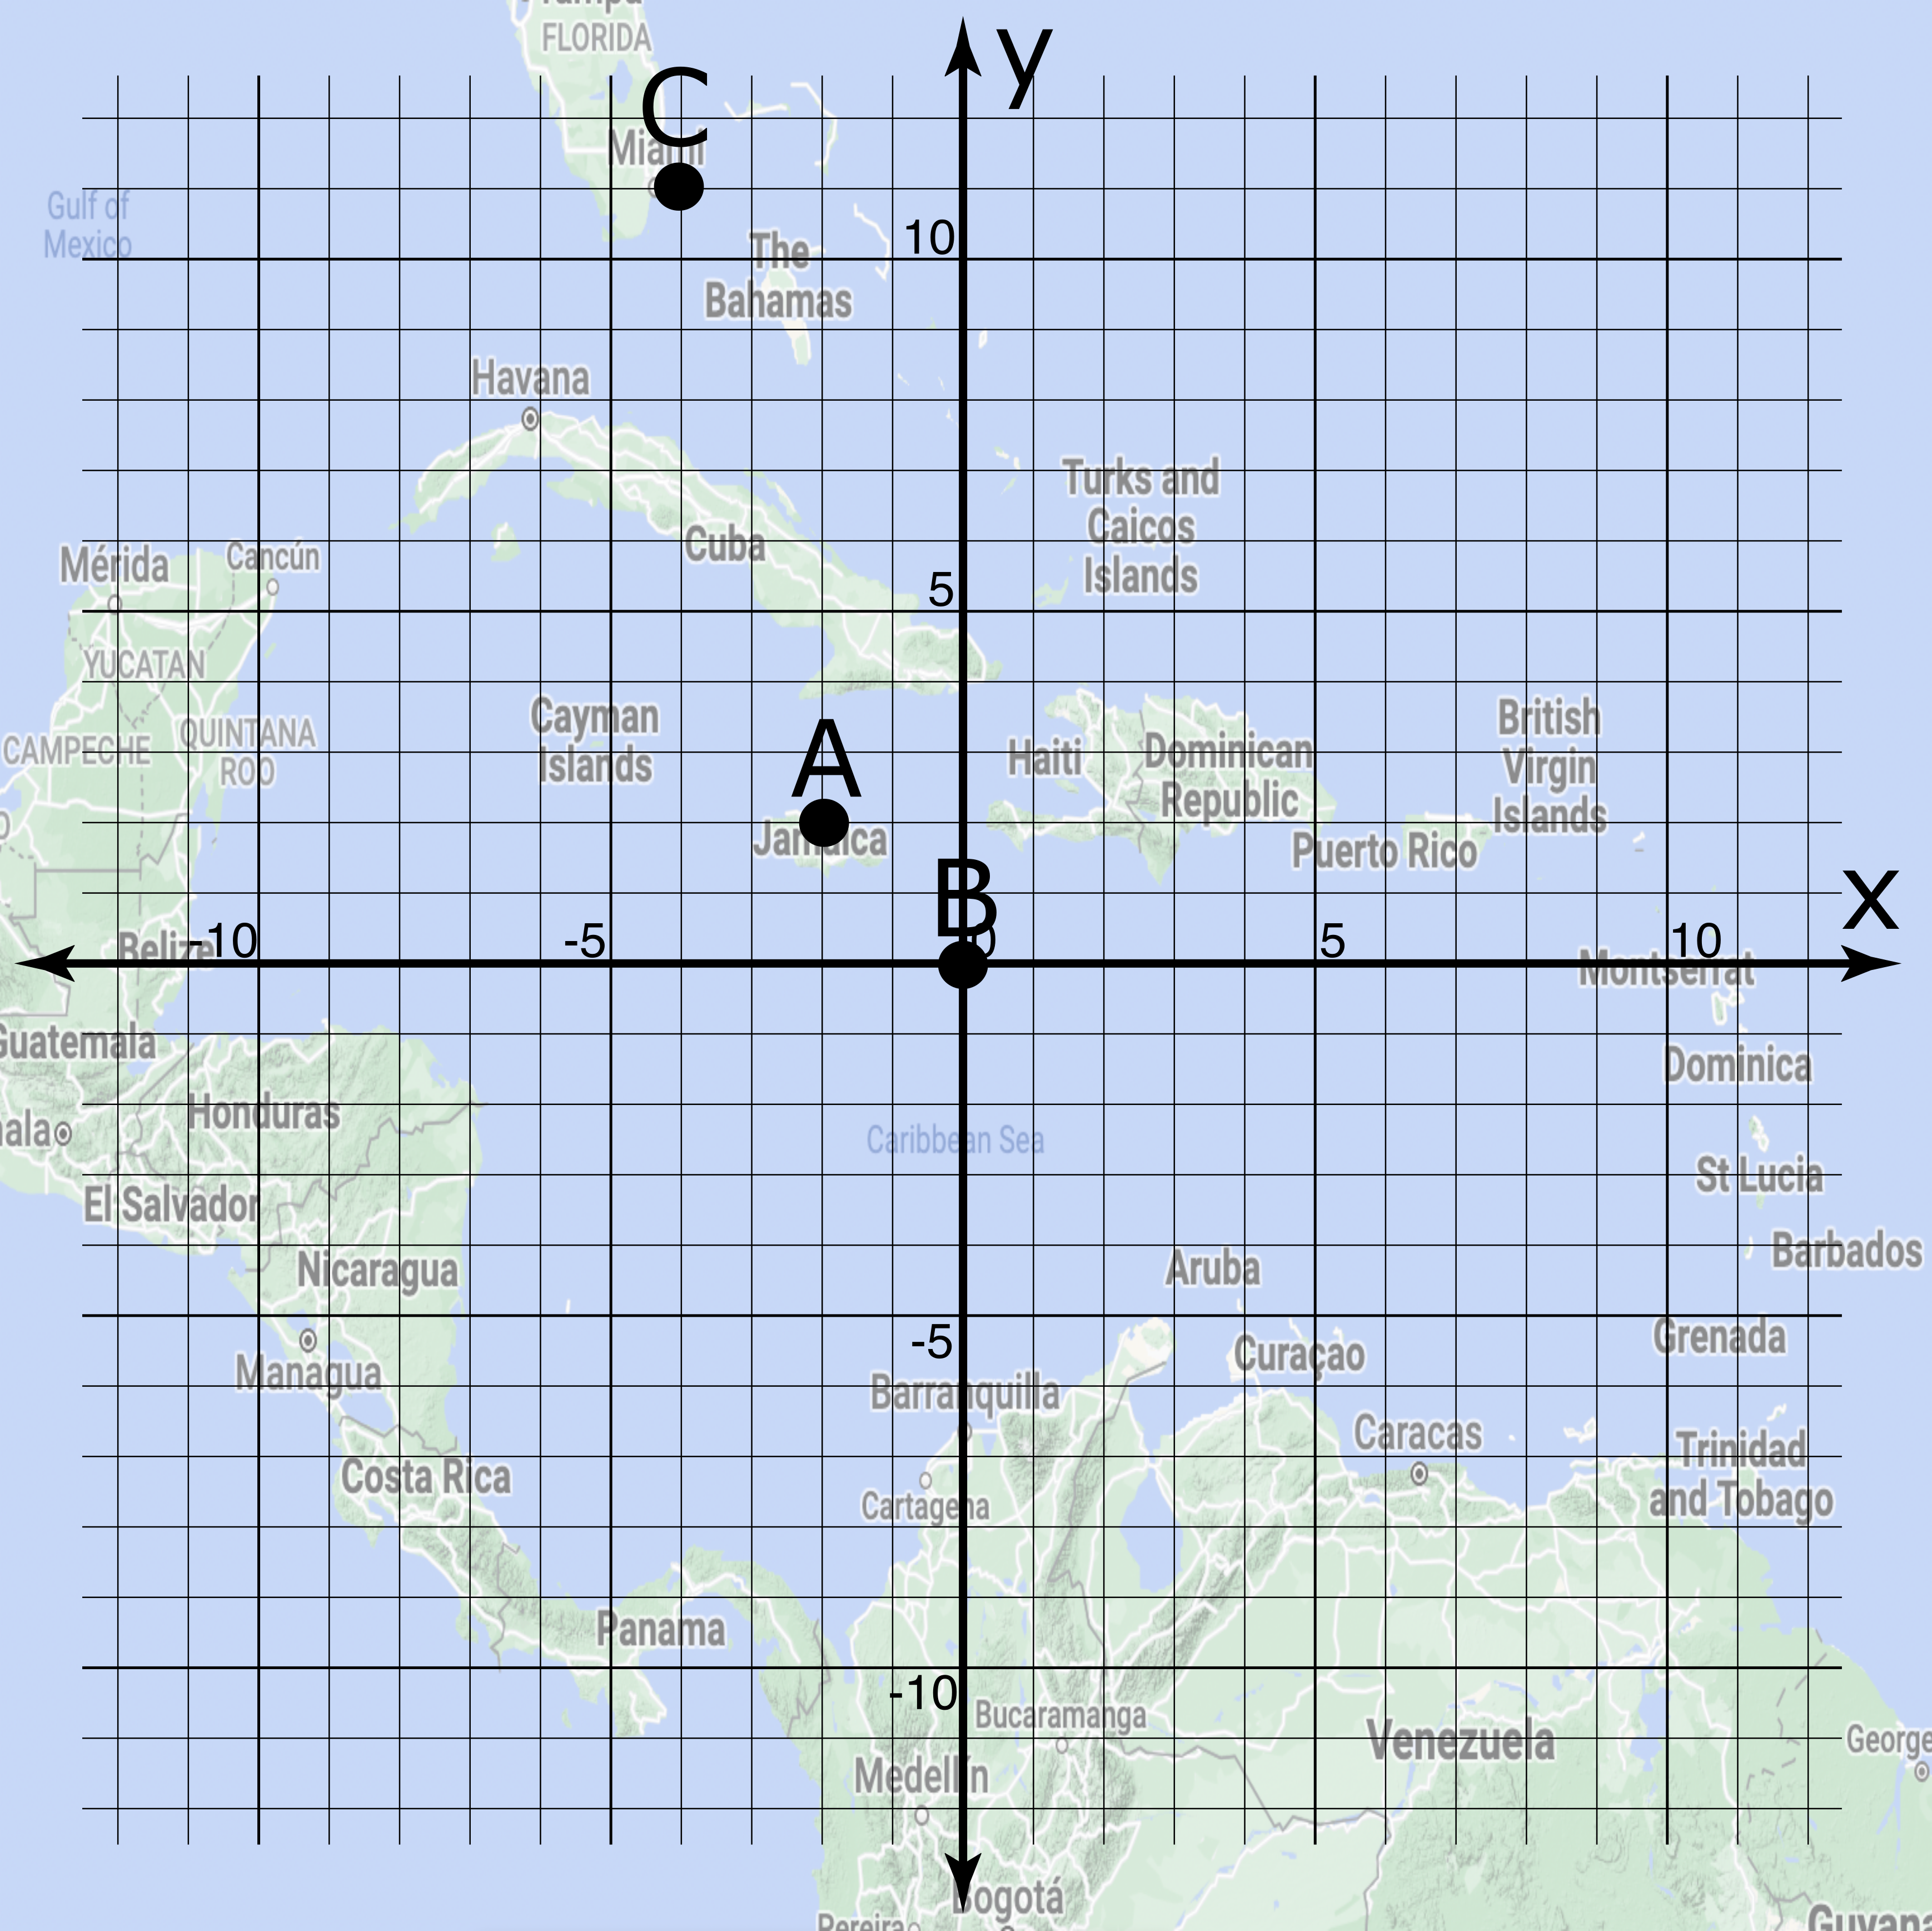
Graph of Set 2:
Set 2 locations:

Point | Location
2A | _________
2B | _________
2C | _________

Set 3
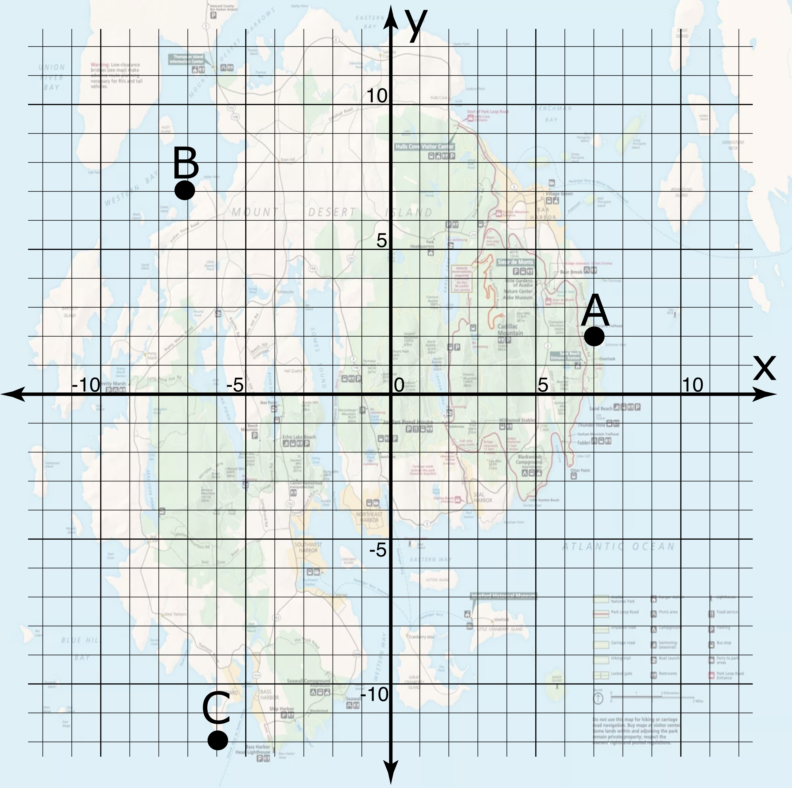
Set 3 locations:
Graph of Set 3:

Point | Location
3A | _________
3B | _________
3C | _________

Extension:
- Create your own set of points A, B, and C on the grid below.
- Exchange this sheet with another group.
- As you did for Sets 1-3, locate each other’s sets on the tarp and record their locations in the table below.
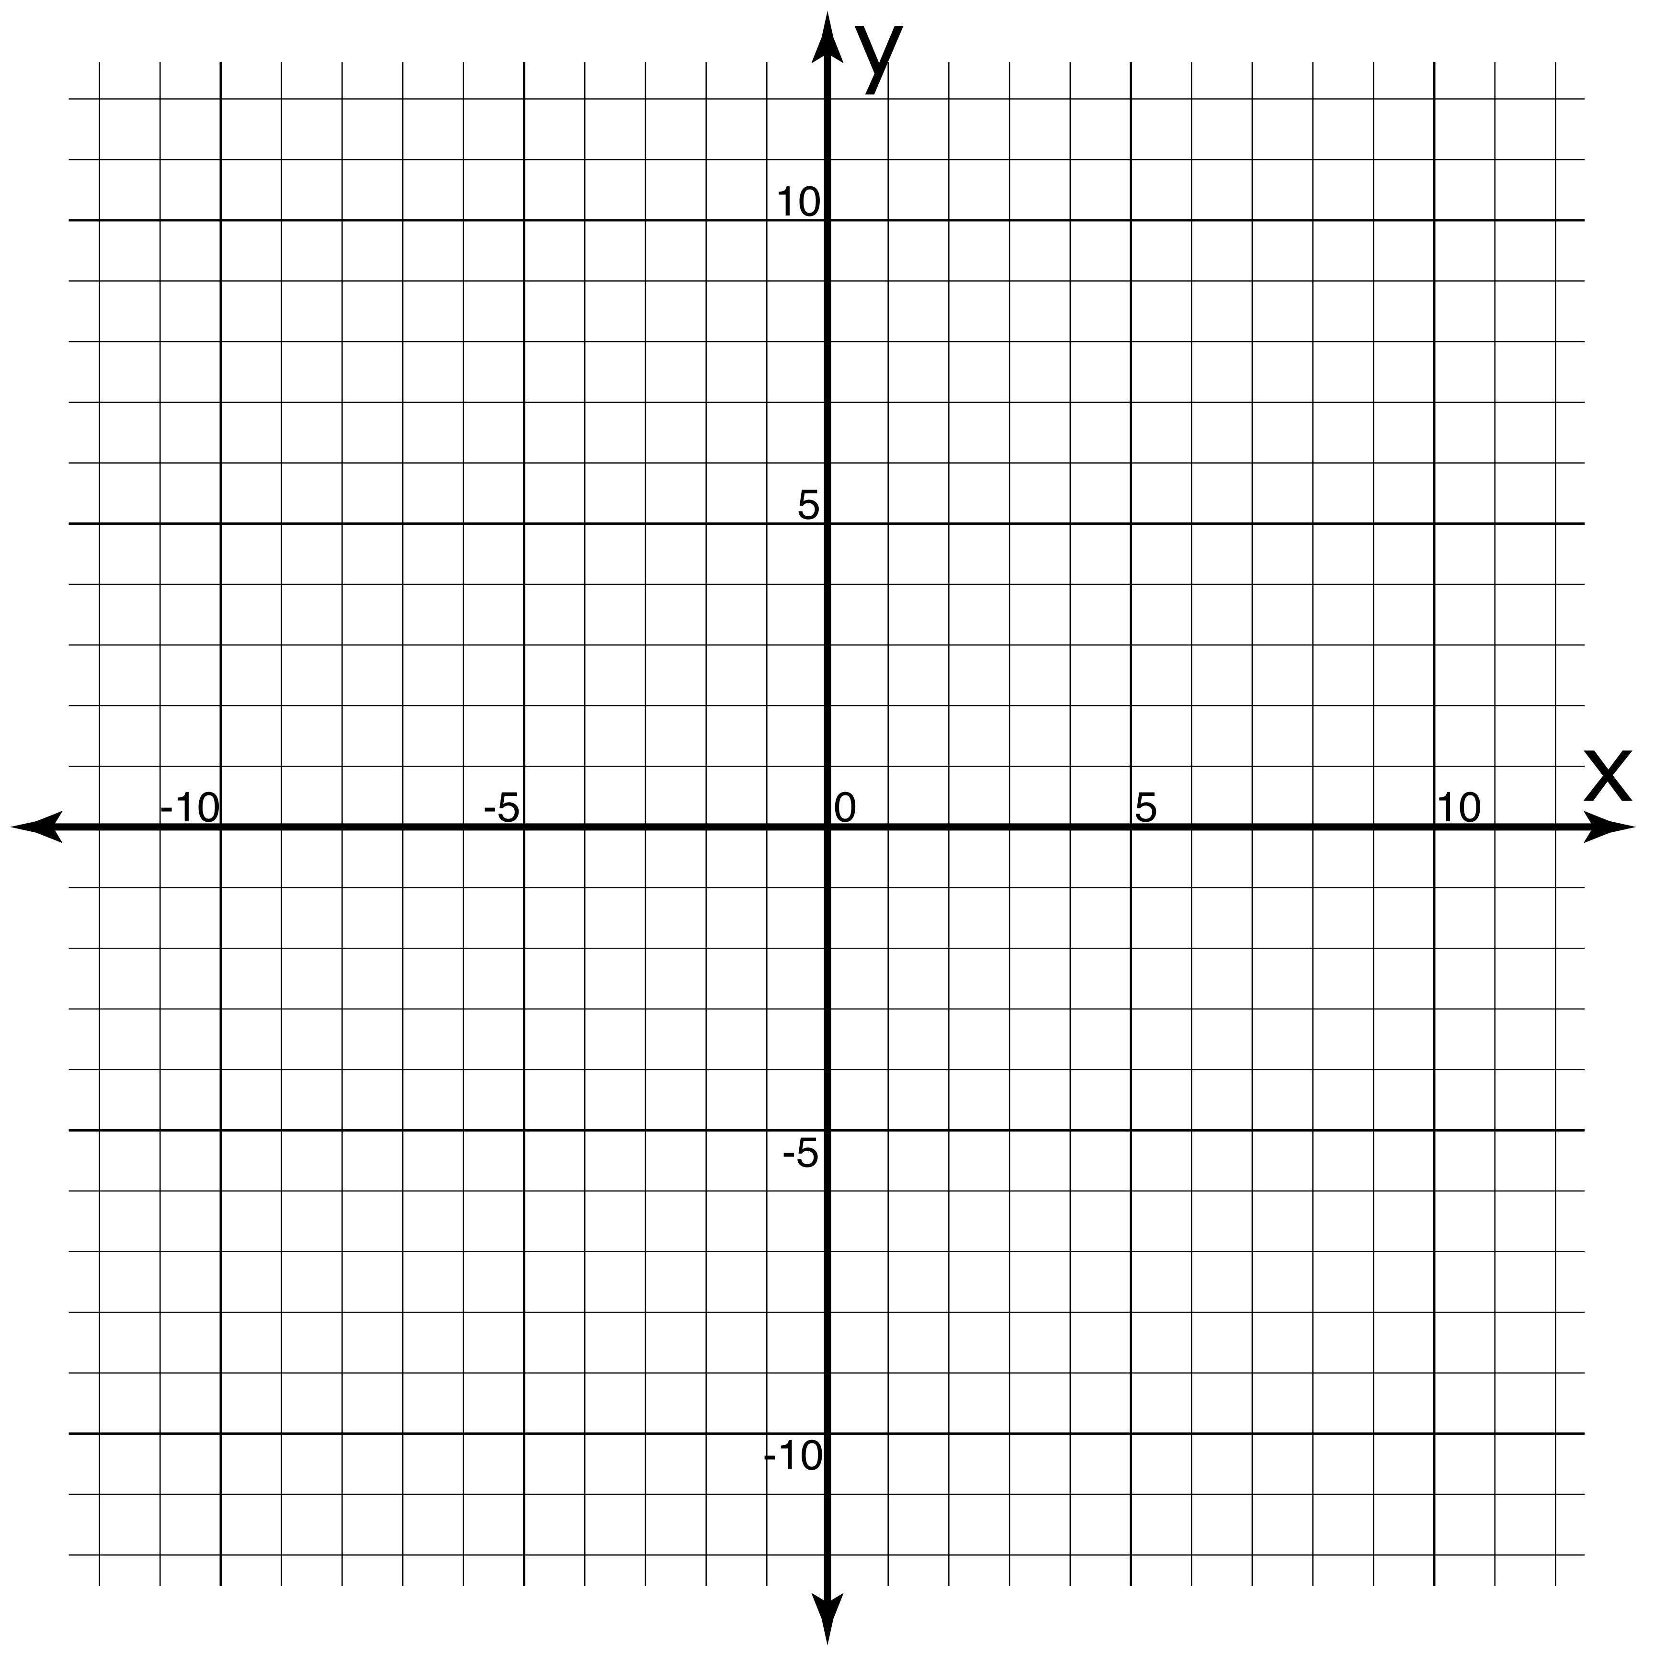
Set of your points:
Your partner groups’ points locations:

Point | Location
A | ________
B | ________
C | ________

Plotting Points Part 2:
From Coordinates to Graphs

Learning Objective: Given an ordered pair, plot the corresponding point on the Cartesian plane.

Recall that ordered pairs are defined by two coordinates (x, y), where x gives the horizontal displacement and y gives the vertical displacement.

Activity:
- Divide your group into 2 teams. Team Tarp grabs the bean bag markers and walks to the tarp. Team Map keeps this activity sheet.
- Team Map instructs Team Tarp to place bean bag markers at points A, B, and C from Set 1 below. How will you communicate where each point is located? What information will help Team Tarp place the markers?
- Once you have placed your markers on the tarp, also sketch their location in the graph for Set 1 below.
- Repeat steps 2 and 3 for Sets 2 and 3.

Set 1
Graph of Set 1:
Set 1 locations:

Point | Location
1A | (4, 3)
1B | (9,11)
1C | (0, 8)

Set 2
Graph of Set 2:
Set 2 locations:

Point | Location
2A | (-1,1)
2B | (-3, 9)
2C | (-2.5, 5)

Set 3
Set 3 locations:
Graph of Set 3:

Point | Location
3A | (-7, -7)
3B | (0, -4)
3C | (11, -6)

Extension:
- Create your own set of points A, B, and C in the table below.
- Exchange this sheet with another group.
- As you did for Sets 1-3, locate each other’s sets on the tarp and record their locations in the graph below.
Graph of your partner groups’ points:
Your points’ coordinates:

Point | Location
A | (__,__)
B | (__,__)
C | (__,__)

